Quiz paper
Name：
1. Which structure is correctly named? （ ）
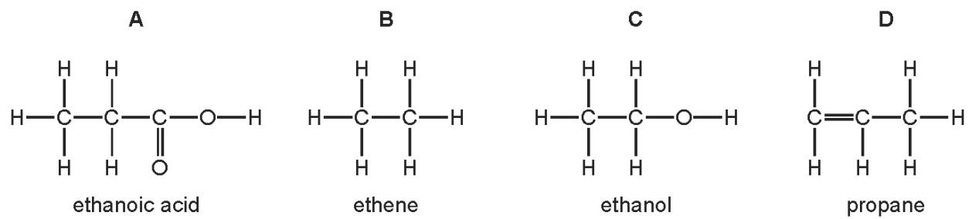

2. Three types of organic compound are alkanes, alkenes and alcohols.
Which structure does not belong to any of these three types of compound? （ ）
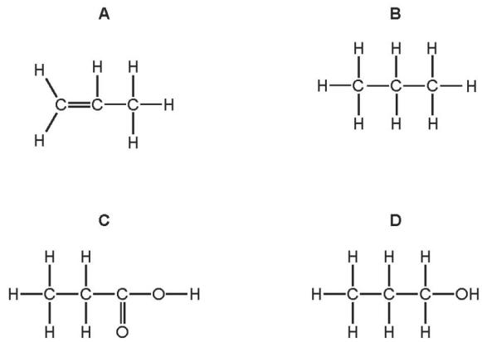
+
3. Which molecular structure shows hexene? （ ）
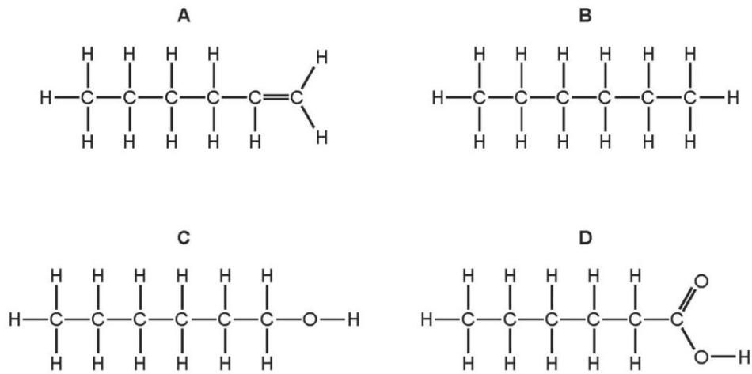

4. Which statement about the names of organic compounds is correct? （ ）
A Compounds containing $C=C$ double bonds are alkanes.
B The compound of formula ${CH}_{3}{CO}_{2}H$ is methanoic acid.
C The compound of formula $C_{2}H_{4}$ is ethane.
D The compound of formula $C_{2}H_{5}OH$ is an alcohol.
5(周测内容)Please write down displayed formulae for these organic compounds
i. CH_{4 :}

ii. C₂H₄

iii. C₄H₁₀

Ⅳ. C₂H₅OH

Ⅳ. C₂H₅COOH

7.(周测内容) Please write down down the names of the following organic compounds
i. C₂H₄
ii. C₃H₈
iii. C₂H₅OH
Ⅳ.C₄H₉OH
Ⅴ. C₂H₅COOH
Ⅵ.HCOOH

